

**Green University of Bangladesh**

**Department of Computer Science and Engineering (CSE)**

**Faculty of Sciences and Engineering**

**Semester: (Fall, Year:2024), B.Sc. in CSE (Day)**

**Lab Report NO: 02**

**Course Title: Computer Networking Lab**

**Course Code: CSE-304 Section:221-D21**

**Lab Experiment Name: Implementation of SMTP for two different networks.**

**Student Details**

| **Name** | | **ID** |
| --- | --- | --- |
| **1.** | Masum Hossain | 221902164 |

**Lab Date : 22/09/2024**

**Submission Date : 15/11/2024**

**Course Teacher’s Name : Md. Saiful Islam Bhuiyan**

| **Lab Report Status**  **Marks: ………………………………… Signature:.....................**  **Comments:.............................................. Date:..............................** |
| --- |

**1. TITLE OF THE LAB REPORT EXPERIMENT**

Implementation of SMTP for Two Different Networks

**2. OBJECTIVES**

The purpose of this experiment was to configure and implement the Simple Mail Transfer Protocol (SMTP) across two distinct networks. The focus was to establish communication between devices on separate subnets to demonstrate email transmission using the SMTP protocol. The objectives of this lab were as follows:

1. To understand the fundamental working principles of SMTP.
2. To configure SMTP servers and clients within a Cisco Packet Tracer simulation.
3. To establish connectivity between two different networks and enable the exchange of email messages.
4. To analyze the flow of email messages across subnets using Packet Tracer simulation tools.

**3. ANALYSIS**

SMTP is a protocol used for sending email messages between servers. In this lab, we created a simulation environment using Cisco Packet Tracer, where two networks were configured to communicate via SMTP. Each network had its own email server and client PCs. Routing and connectivity were ensured between the networks.

The key steps of this experiment:

**Network Design:** Two distinct networks were created, each with its own IP addressing scheme.

**SMTP Server Configuration:** Email servers in both networks were configured with appropriate settings, including domain names and user accounts.

**Client Setup:** PCs in both networks were configured with email client software and user credentials for the SMTP servers.

**Routing Configuration:** Routers were set up to enable communication between the two networks.

**Testing Email Transmission:** Email messages were sent from a client in one network to a client in the other, ensuring successful message delivery.

**4. IMPLEMENTATION**

### **Steps in the Implementation:**

* **Network Setup:**
  + Created two networks with separate subnets (2.168.1.0 and 192.168.2.0).
  + Configured routers with static routes or dynamic routing protocols to establish connectivity between the subnets.
* **SMTP Server Configuration:**
  + Deployed SMTP servers in both networks using Cisco Packet Tracer's server functionality.
  + Added user accounts on each server (rahim@gmail.com and akhi@gmail.com).
* **Client Configuration:**
  + Configured PCs with email client software to connect to the SMTP servers using the assigned user credentials.
* **Connectivity Testing:**
  + Verified inter-network communication by pinging devices across the networks.
* **Email Testing:**
  + Send emails from one network’s client to the other. Monitored the flow of packets to ensure successful delivery.

**OUTPUT**

The simulation showed successful email transmission between the two networks. SMTP messages were observed traversing through routers, demonstrating proper protocol implementation and routing.Here a screenshot is included to demonstrate the process.

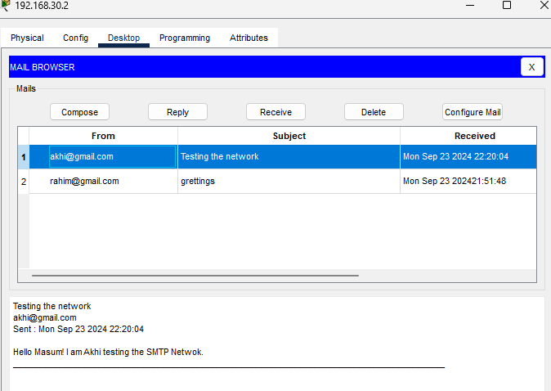

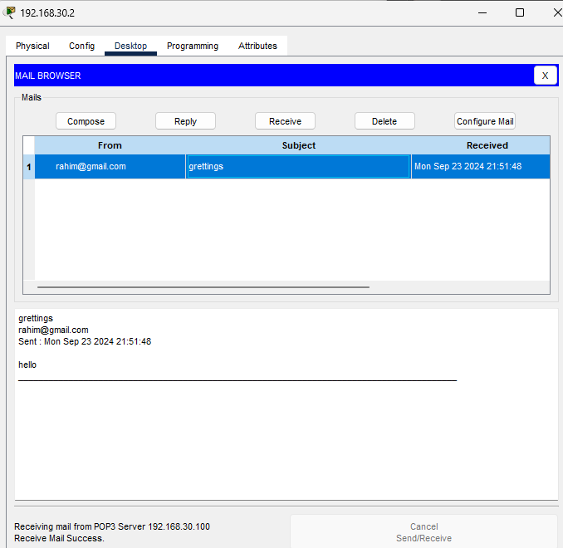

| **Fig 01: Showing email flow between the networks.** |
| --- |

**6. ANALYSIS AND DISCUSSION**

The experiment successfully demonstrated the implementation of SMTP for communication between two distinct networks.Proper configuration of routers and routing tables was critical to establishing seamless connectivity between the networks. Packet Tracer's simulation tools provided valuable insights by enabling the analysis of packet flow, allowing us to observe the functionality of the SMTP protocol in detail. Despite initial challenges with routing configurations and SMTP server settings, systematic troubleshooting ensured successful email transmission. This exercise emphasized the importance of protocol knowledge and accurate network configuration in achieving efficient communication between devices in separate networks which was successfully implemented in this lab experiment.